|  |  |  |  |  |  |  |  |  |  |  |  |  |  |  |  |  |  |  |  |  |  |  |  |  |
| --- | --- | --- | --- | --- | --- | --- | --- | --- | --- | --- | --- | --- | --- | --- | --- | --- | --- | --- | --- | --- | --- | --- | --- | --- |
| |  |  | | --- | --- | | For office use only | | | T1 | ________________ | | T2 | ________________ | | T3 | ________________ | | T4 | ________________ | | |  | | --- | | Team Control Number **18430300** | | **A** | | |  |  | | --- | --- | | For office use only | | | F1 | ________________ | | F2 | ________________ | | F3 | ________________ | | F4 | ________________ | |

**IMMC 2018**

**The 4th Annual International Mathematical Modeling Challenge (Winter Contest)**

**Summary Sheet**

The transition time between transport modes greatly effects transportation efficiency. In this project, we worked on making a plan for a public transit hub in order to make it economically optimized for the society.

In Model A, we planned how the functional regions should be distributed on the floors. One factor we used to evaluate plans is the average distance a passenger has to walk, taking the difference between travelling vertically and horizontally into account. In order to assess the economic effect of shortening distances in terms of money, we equalized the economic losses to the amount of value that could have been produced in the time wasted, indicated by the region’s GDP. In this way, we can evaluate the plans by the total construction costs and the time wasted as a whole, and have more comprehensive results.

In Model B, we focused on planning the locations of the escalators. We considered three factors: extra distance, disorder from collision, and escalator redundancy. Limited by the locations of the escalators, passengers have to cover more distance than the minimum value, and thereby waste time; and when passengers’ routes cross, they collide and have to slower their speeds, also taking more time. We also evaluate the redundancy when too many escalators are built and not sufficiently used. With redundancy, we also considered the fluctuation that might exist in exchange volume, and calculated the amount of redundancy needed to prevent congestion according to the degree of unevenness of the flow of passengers.

In both the floor plan model and the escalator plan，we used the genetic algorithm to generate optimized plans. The plan we finally decided on has the walking area, the high-speed railway station and the bus terminus on the ground floor, and the light railway station and the walking area on the first floor. It has one escalator, located in the middle of the building. We also tested our model’s sensibility to the constants that we used, and found that it is quite steady and reliable.

|  |
| --- |
| At the Cross of Traffic  Team#18430300  Feb.2, 2018 |

**Contents**

1. Introduction 4

2. General assumptions 4

3. Model A: Floor planning 5

3.1 Model overview 5

3.2 Defining transition 5

3.3 Constants and variables 5

3.4 The average distance 6

3.5 Time is money 8

4. Model B: Escalator arrangement 9

4.1 Model overview 9

4.2 Variables of Model B 9

4.3 Additional distances 10

4.4 Disorder from collision 11

4.5 Escalator redundancy 12

4.6 The final escalator plan 13

4.7 A glance at congestion 13

5. Sensitive analysis 15

5.1 Sensitivity of $Ee$ versus passengers’ sectional area 15

5.2 Sensitivity of $Ee$ versus the walking speed 16

5.3 Sensitivity of $Ee$ versus $k$ 17

5.4 Sensitivity of $Ee$ versus the GDP 17

6. Strengths and weaknesses 18

6.1 Strengths 18

6.2 Weaknesses 19

7. References 20

1. Introduction

Various means of transportation such as walking, bus, taxi, light railway and high speed train join up to speed up our life. In this process, transition between different means greatly effects the efficiency of transportation, and is therefore of great importance. In this problem, we pay attention to the designing of a new public transit hub in H City, which links transportation modes together and aims to shorten passenger exchange times while keeping budgets reasonable.

1. General assumptions
2. We do not consider obstacles in any functional region.

Due to their small sizes, the functional regions can only serve as connecters to different transportation modes instead of functional organs themselves. Therefore, we do not consider obstacles such as railways inside the regions. When a passenger enters a functional region, he can directly move to any part of the region.

1. The space taken by entrances and exits counts into functional regions’ space.

Gates, passages, escalators and elevators to and from functional regions enable passengers to reach the transport modes, and therefore play an important part in the regions’ function, so the space they take should also be included in the space regions require.

1. Passengers choose the shortest paths to their destinations.

We assume that the passengers choose the shortest paths available in order to save time.

1. The stairs, elevators and escalators we use accord with Chinese underground designing regulations.

The standards in the Chinese underground regulations represent a reasonable solution to public transportation designing, and through these standards we can estimate the actual equipment’s parameters.

5. The transit hub’s condition remains the same throughout its life span.

We use the transit hub’s current exchange volumes to predict its future condition.

6. All the passengers are the same in size and physical agility.

Vary as these features are, their variance cannot cause significant effect on the larger scale. Therefore, we use the “average person” to represent all of the passengers.

1. Model A: Floor planning

3.1 Model overview

In this model, we define the process of transition, and thereby calculate the average transit distance a passenger has to cover. Then, we calculate the loss caused by this wasted time, and by adding up the construction costs, we develop a method to evaluate a plan’s economic excellence in both social benefits and its costs. Finally, we use the genetic algorithm to generate an optimized plan for floor planning.

3.2 Defining transition

As we can infer from the data given, the transit hub we design only serves as a connecter. (Otherwise it would be too small—for example, a high speed train is about 201 meters long[1] and is not likely to stop in a station only 100 meters long.) After finishing using one transport mode, the passenger enters its functional region through a corridor, door or gate, walks through the region, reaches the functional region of the transport mode he desires to use, and leaves the later region through the nearest entrance to the actual area of the mode.

As in most actual stations, each transport mode has several gates, doors or corridors (for short “gates”) leading to its functional region so as to avoid congestion. These gates are distributed on the outer edge of the region, and are both the entrances to the regions and the exits from the regions. As entrances, we assume that each gate welcomes the same number of arriving passengers, for arriving passengers come from different directions fairly distributed, such as in the high-speed train case, passengers from different carriages tend to choose the different entrances nearest to them; as exits, as the gates have different distances to the gates the passengers came from, passengers tend to choose the nearest gates as their destinations. We see the gates as dots, name them according to their corresponding transport modes, and use their coordination to describe them.

According to regulations, in public transportation areas, every escalator should be accompanied with stairs as well as barrier-free elevators. In short, we call a set of these three an “escalator”.

3.3 Constants and variables

In the following table are the constants and variables used in the evaluation model.

|  |  |
| --- | --- |
| Constants | Definition |
| W | The Walking region. |
| B | The Bus region. |
| T | The Taxi region. |
| H | The High-speed train region. |
| L | The Light railway region. |
| $$k$$ | The vertical-horizonal distance coefficient. |
| $$v$$ | The average walking speed. |
| $$P$$ | The annual GDP of the region. |
| $$t$$ | The transit hub’s life span. |
| $$C_{Mi}$$ | Region M’s construction cost M on *i*th floor. |
| Variables | Definition |
| $$M_{i}(x_{M_{i}},y_{M_{i}},z_{M_{i}})$$ | The $i^{th}$ gate of the region M. |
| $$n_{M}$$ | The total number of gates in region M. (W for walking, etc.) |
| $$S_{M_{i},N_{j}}$$ | The distance between gates $M_{i}$ and $N_{j}$. |
| $$\overline{S_{MN}}$$ | The average distance between regions M and N. |
| $$σ$$ | The total exchange volume. |
| $$σ_{MN}$$ | The exchange volume between regions M and N. |
| $$\overline{S}$$ | The average transit distance of the plan. |
| $$V$$ | The amount of wasted value. |
| $$D_{Mi}$$ | The space region M takes on the *i*th floor. |
| $$C$$ | The total construction cost of the plan. |
| $$E_{f}$$ | The economic factor of the floor plan. |
|  |  |

**Table 1** Constants and Variables for the evaluation model

3.4 The average distance

With the coordination of gates $M_{i}$ and $N_{j}$, we can calculate the horizonal distance between the two gates, which is:

$$\sqrt{{\left(x_{M_{i}}-x_{N_{j}}\right)}^{2}+{\left({y_{M}}_{i}-y_{N_{j}}\right)}^{2}}$$

When dealing with the vertical distance, however, the case is different. Compared to the same distance horizontally, covering vertical distance usually requires an escalator, and spends a different amount of time. It should also be noticed that when a passenger takes an escalator, he also covers a horizonal distance decided by the direction of the escalator. Sometimes, the escalator brings him closer to his destination horizontally; but in other occasions, it can also hinder him, and hence we consider this effect offset at a larger scale. Therefore, we can suppose that a certain vertical distance is equivalent to k times the distance horizontally, and get:

$$S_{M_{i}N_{j}}=\sqrt{{\left(x_{M_{i}}-x_{N_{j}}\right)}^{2}+{\left({y_{M}}_{i}-y_{N_{j}}\right)}^{2}}+k|z_{M_{i}}-z_{N_{j}}|$$

By consulting *Metro Designing Standards* [1], we find that escalators must be accompanied with stairs, while each stair should be about 0.334 meters long, 0.167 meters high, and between every 18 stairs there should be a rest platform 1.5 meters long, as shown in the figure below. As the escalator and stairs share the same ends, we can therefore deduce that a 15-meter-tall escalator should be 36 meters long. As the escalator’s speed should be 0.65m/s, we can calculate that its vertical speed is 0.25m/s, while the average person’s walking speed is 1.5m/s [2]. Thus, we can calculate that moving vertically takes 6 times the time of moving horizontally, which means that $k$ is about 6.

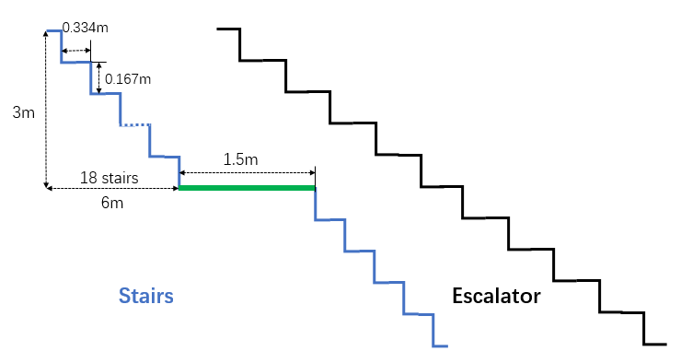

**Figure 1** Parameters of the stairs

As the gates of region M welcome the same amount of passengers, we can thereby calculate the average distance from region M to N:

$$\overline{S_{MN}}=\frac{\sum_{i=1}^{n_{M}}{[(\sqrt{{\left(x_{M_{i}}-x_{N_{j}}\right)}^{2}+{\left({y_{M}}_{i}-y_{N_{j}}\right)}^{2}}+k|z_{M_{i}}-z_{N_{j}}|})min]⁡}{n_{M}}, j=1,2,…,n_{N}$$

In which we name the collection of routes $M_{i}N_{j}$ which are the shortest routes from $M_{i}$ to an N gate set $\{R_{S}\}$.

Our aim is to improve passenger experience, so we should put more emphasis on the transitions that have larger exchange volumes. In this case, we used the proportion of the passenger exchange volume between regions M and N in the total exchange volume as the transition’s weight, as in the formula:

$$\overline{S}=\sum_{M,N∈\{W,B,T,H,L\}}{\frac{σ_{MN}}{σ}∙\overline{S_{MN}}}$$

3.5 Time is money

By costs, we include both the functional regions’ construction costs and the loss caused by the time of the passengers wasted. In this section, we use the region’s annual GDP per capita to evaluate the value the passengers could have produced in the time they wasted. The time wasted per passenger can be calculated by dividing the average transit distance by the average walking speed, while the GDP per capita is multiplied by the total exchange volume in the hub’s life span, which is:

$$V=\frac{\overline{S}}{v}∙P∙σ∙t$$

As important buildings require massive repair and further investment after years of use, we regard the hub’s life span as the time until its repairing. We estimate that its life span is 10 years.

We use the average GDP per capita of China, 4500 yuan per month [4], in our model. The variation of this data will be discussed in Sensitivity Analysis.  
We use $D_{Mi}$ to indicate how much space region M takes on floor $i$, and use $C_{Mi}$ to indicate how much the construction cost of region M on floor $i$ is. By multiplying the regions’ distribution and the construction costs, we can get the total construction cost:

$$C=\sum_{Mϵ\{W,B,T,H,L\}}{\sum_{i=-3}^{3}{C_{Mi}∙D_{Mi}}}$$

Now, we can add up both the costs and calculate the overall economic factor E, which should be as small as possible:

$$E_{f}=C+V$$

Using the genetic algorithm, we can optimize our floor arrangement plan and generate an economically good solution. The plan we generated is shown in the figure below.

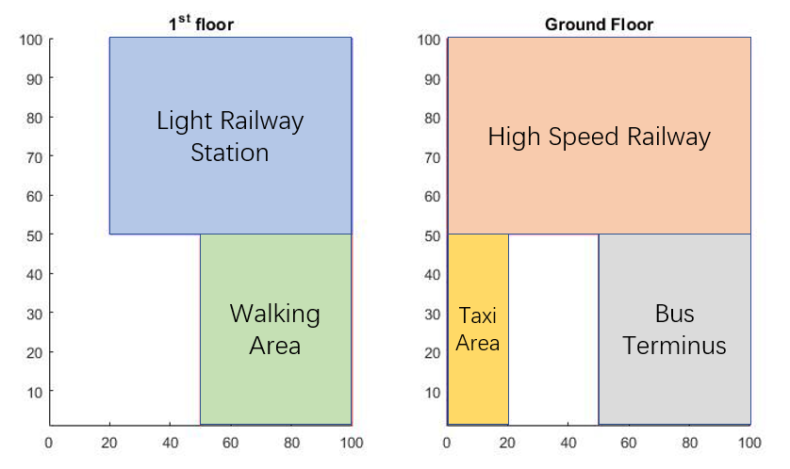

**Figure 2** The optimized floor plan

1. Model B: Escalator arrangement

4.1 Model overview

In Model A, we found the economically optimized floor arrangement plan according to the regions’ distances and costs. In Model B, we focus on deciding the specific positions of the escalators, stairs and elevators in order to shorten passengers’ actual walking distances, avoid escalator congestion as well as save space and resources.

4.2 Variables of Model B

|  |  |
| --- | --- |
| Constants | Definition |
| $$L_{E}$$ | The length of an escalator. |
| $$v$$ | The walking speed of a passenger. |
| $$d_{P}$$ | The width of a passenger. |
| $$T_{P}$$ | The thickness of a passenger. |
| $$C_{E}$$ | The maximum capability of an escalator. |
| $$P_{E}$$ | The price of an escalator. |
|  |  |
| Variables | Definition |
| $$E_{i}(x_{E_{i}0},y_{E_{i}0},x_{E_{i}1},y_{E_{i}1})$$ | The escalator $E_{i}$. |
| $$d_{M_{i}N_{j}}$$ | The actual distance between $M_{i} and N_{j}$. |
| $${∆d}_{M_{i}N_{j}}$$ | The additional distance between $M_{i} and N_{j}$. |
| $$t_{∆d}$$ | The amount of time wasted due to the additional distances. |
| $$θ_{M_{i}N_{j},O_{k}P_{l}}$$ | The angle between routes $M_{i}N_{j}$ and $O_{k}P_{l}$’s directions. |
| $$t_{CD}$$ | The time wasted by disorder from collision. |
| $$R_{E_{i}}$$ | The redundancy of escalator $E_{i}$. |
| $$R_{T}(E_{i})$$ | The target redundancy for escalator $E_{i}$. |
| $$C_{E}$$ | The cost of redundant escalators. |
| $$μ_{E_{i}}$$ | The average exchange volume of escalator $E_{i}$. |
| $$σ_{E_{i}}$$ | The variance of the exchange volume of $E_{i}.$ |
| $$E_{e}$$ | The economic factor of the escalator plan. |
|  |  |

**Table 2** Constants and Variables: Escalator arrangement

4.3 Additional distances

In actual situations, limited by the positions of escalators, passengers are forced to deviate from the closest path to their destinations and turn to escalators. We describe the elevator $E_{i}$ by the coordination of its two ends on the ground floor and on the first floor, which is $E_{i}(x_{E_{i}0},y_{E_{i}0},x_{E_{i}1},y_{E_{i}1})$. As the length of an escalator is $L_{E}$, we can deduce that:

$${\left(x_{E_{i}0}-x_{E_{i}1}\right)}^{2}+{\left({y_{E_{i}0}-y}_{E_{i}1}\right)}^{2}=L_{E}^{2}$$

Therefore, for a passenger travelling from $M_{i}$ on the ground floor to $N_{j}$ on the first floor, the actual distance he has to cover, in which $E_{i}$ is the elevator that makes his route the shortest, is:

$$d_{M_{i}N_{j}}=\sqrt{{\left(x_{M_{i}}-x_{E_{i}0}\right)}^{2}+{\left({y_{M}}_{i}-y_{E_{i}0}\right)}^{2}}+\sqrt{{\left(x_{N_{j}}-x_{E_{i}1}\right)}^{2}+{\left(y_{N_{j}}-y_{E_{i}1}\right)}^{2}}+L_{E}$$

So the additional distance he has to cover due to deviation is:

$${∆d}_{M_{i}N_{j}}=d_{M_{i}N_{j}}-\sqrt{{\left(x_{M_{i}}-x_{N_{j}}\right)}^{2}+{\left({y_{M}}_{i}-y_{N_{j}}\right)}^{2}}$$

Thereby, we can calculate the amount of time wasted due to the additional distances:

$$t_{∆d}=\frac{\sum_{M_{i}N_{j}ϵ\{R_{S}\}}{{∆d}_{M_{i}N_{j}}∙σ_{M_{i}N_{j}}}}{v}$$

4.4 Disorder from collision

With the great number of passengers travelling in the hub in different directions, it cannot be avoided that some passengers’ routes cross with each other’s, and therefore a passenger has to slow down his pace in order not to collide. When too many routes cross, the slowing down happens frequently and causes disorder. As to avoid this kind of situation, we added the time wasted by collision into the evaluation model for escalator plans.

Imagine two passengers A and B, with widths of $d_{P}$, travelling in two routes that cross at speed $v$ and meeting, as in Figure 3(a). The angle between their directions is $θ$. We assume that A crosses first, and B has to go behind him. In stage (a), A’s speed in B’s direction is $vcosθ$, smaller than B’s maximum speed, which means that B can only move at this speed and therefore wastes time. After stage (b), however, A’s speed in B’s direction becomes $\frac{v}{cosθ}$, and both passengers can move at their maximum speeds.

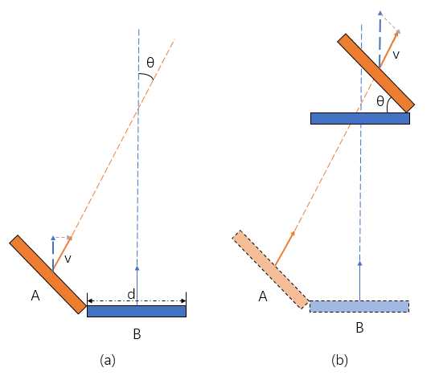

**Figure 3** A and B colliding

We can calculate that the distance A covered is $\frac{d_{P}}{sinθ}$, so the time of this process is $\frac{d_{P}}{vsinθ}$. Originally, B would only use $\frac{d_{P}cotθ}{v}$. Therefore, the time wasted is:

$$\frac{d_{P}}{vsinθ}-\frac{d_{P}cotθ}{v}=\frac{d_{P}\left(1-cosθ\right)}{vsinθ}$$

For the route $M_{i}N_{j}$, with an hourly exchange volume of $σ_{M_{i}N_{j}}$ and a length of $d_{M_{i}N_{j}}$, we can deduce that at the same time the number of passengers on the route is:

$$\frac{d_{M_{i}N_{j}}}{v}∙σ_{M_{i}N_{j}}$$

Therefore, as the average person’s thickness is $T_{P}$, the possibility of the person on route $O_{k}P_{l}$ to collide with a person on $M_{i}N_{j}$ and be delayed is:

$$\frac{\frac{d_{M_{i}N_{j}}}{v}∙σ_{M_{i}N_{j}}∙T_{P}}{{2d}_{M_{i}N_{j}}}$$

So the total time wasted by collision per hour at the cross point of $M_{i}N_{j}$ and $O_{k}P_{l}$ is:

$$\frac{\frac{d_{M_{i}N_{j}}}{v}∙σ_{M_{i}N_{j}}∙T_{P}}{2d_{M_{i}N_{j}}}∙σ_{O_{k}P_{l}}∙\frac{d_{P}\left(1-cosθ_{M_{i}N_{j},O_{k}P_{l}}\right)}{vsinθ_{M_{i}N_{j},O_{k}P_{l}}}$$

By summing up the delayed time at each crossing, we can calculate that the total time wasted by the collision disorder is:

$$t_{CD}=\sum_{(M_{i}N_{j},O_{k}P_{i})∈\{R_{c}\}}{\frac{\frac{d_{M_{i}N_{j}}}{v}∙σ_{M_{i}N_{j}}∙T_{P}}{2d_{M_{i}N_{j}}}∙σ_{O_{k}P_{l}}∙\frac{d_{P}\left(1-cosθ_{M_{i}N_{j},O_{k}P_{l}}\right)}{vsinθ_{M_{i}N_{j},O_{k}P_{l}}}}$$

In which $\{R_{C}\}$ is a set composed of all the route crossings.

4.5 Escalator redundancy

When an escalator’s capability is larger than needed, the unused part of its capability can be regarded as redundant. While the total capacity $C_{E}$ can be calculated by parameters of the escalator, the used part is the sum of all the passengers that choose this escalator as its passage. By calculation, we put all the routes $M_{i}N_{j}$ that use escalator $E_{i}$ into the set $\{R_{{PE}_{i}}\}$. Then we can calculate the redundancy rate of escalator $E_{i}$:

$$R_{E_{i}}=1-\frac{\sum_{M_{i}N_{j}ϵ\left\{R_{PE_{i}}\right\}}{σ_{M_{i}N_{j}}}}{C_{E}}$$

As the situation is located in a transit hub, it is likely that many passengers would be carrying large pieces of luggage and unwilling to move vertically by stairs, and only a small percentage of people climb stairs when the escalator is overpacked. Therefore, we see the stairs’ capacity as 5% of that of the escalators. Meanwhile, an escalator’s capacity is 7200 passengers per hour, and the elevator’s capacity 1200 passengers per hour [1]. Hence, the “escalator” has a maximum capacity of 8760 passengers per hour.

When $R_{E_{i}}$ is larger than 0, this indicates that the escalator still has spare capacity; when it is 0, the escalator is perfectly full; when it is smaller than 0, the load of the escalator is larger than its capacity, and passengers will accumulate and cause major congestion. In this model, we assume that the exchange volume remains uniform throughout the time, on which we will further consider in ***4.7*** *A Glance at Congestion*. Therefore, the escalator’s condition, which is redundant, perfectly full or congested, is constant. Hence, we should keep every escalator’s redundant rate at or above zero, and as close to zero as possible.

We sum up the redundancy rates of all $n_{E}$ escalators, which is equal to the number of escalators that are wasted. Therefore, as the price of an escalator is $P_{E}$, the cost of redundancy is:

$$C_{E}=P_{E}∙R=P_{E}∙\sum_{i=1}^{n_{E}}{R_{E_{i}}}$$

4.6 The final escalator plan

With the evaluations of additional distances, disorder caused by collisions and escalator redundancy, we can synthesize these factors into a final escalator cost, which is the wasted time multiplied with the benefits of time (such as in ***3.5*** *Time is Money*) added up with the cost of wasted elevators. It can be written as:

$$E_{e}=\left(t_{∆d}+t_{CD}\right)∙P∙t+C_{E}$$

By using the genetic algorithm, we came to the escalator plan with the smallest $E_{e}$. Our final plan is shown in the figure below, in which the grey block is the escalator, and the dark end is connected to the current floor in each ichnography.

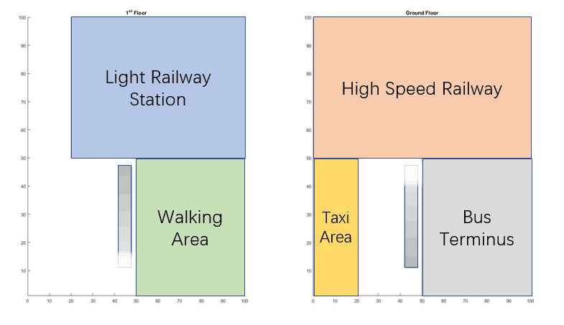

**Figure 4** Final escalator plan

4.7 A glance at congestion

As mentioned in the redundancy section above, congestion occurs when the income speed of passengers surpasses the output speed at an elevator. When the income speed is constant, the status of an elevator remains the same, and we should lower redundancy as much as possible; but when we consider the fluctuation of income speed, congestion may occur when not enough redundancy is obligated. In this section, we calculate how much redundancy should be obligated in order to prevent congestion during peak times.

As the passengers entering the transit hub come from various sources of great uncertainty, we can assume that the passengers’ arrivals are random processes. As we can infer from the table given, the average exchange volume between two transport modes is certain. Therefore, we only have to decide how the process’s nonuniformity characteristics effect the seriousness of the congestion.

A paper in 2013, *Gaussian Traffic Revisited* [3], demonstrated that the amount of network congestion fitted well to the Gaussian distribution. We find that traffic through the escalators had many similar features with network traffic. The passengers come in randomly, and they were uncorrelated with each other, like the users in a network; and the escalator’s maximum capability is limited by its width such as with the bandwidth of a network. Therefore, we apply this Gaussian feature into our model of congestion.

We assume that the gaussian distribution of passenger arrivals at elevator $E_{i}$ is $N\left(μ_{E_{i}},{σ_{E_{i}} }^{2}\right).$ It is generally accepted that when dealing with a gaussian distribution, the possibility of a value beyond the interval $[μ_{E_{i}}-3σ_{E_{i}},μ_{E_{i}}+3σ_{E_{i}}]$ is so small that the extreme situation can be neglected. Hence, we set our “Target Redundancy” $R_{T}$, which is the ideal amount of redundancy that we should have, at the point where it can allow as many passengers as $μ_{E_{i}}+3σ_{E_{i}}$ to pass smoothly.

Therefore, we can calculate that the target redundancy for escalator $E_{i}$ is:

$$R_{T}(E_{i})=1-\frac{μ_{E_{i}}}{μ_{E_{i}}+3σ_{E_{i}}}$$

For an elevator with an average exchange volume of 5100 passengers, for example, as the variance changes, the target redundancy changes as in Figure 5 below. In Figure 5, we also show the corresponding distributions of passenger arrival of two variances in the figure.

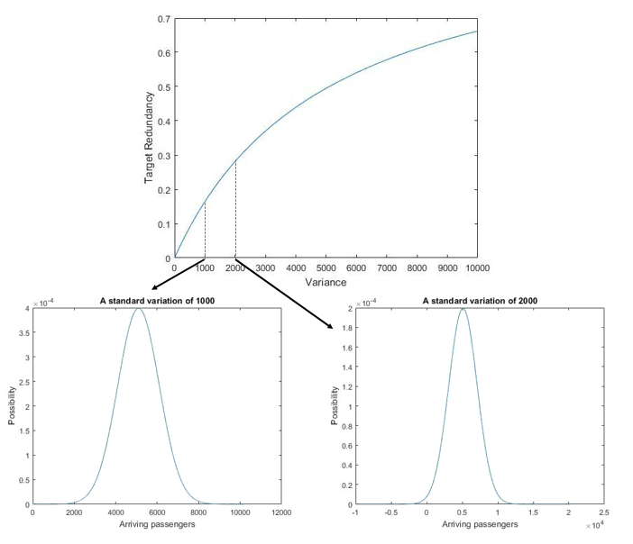

**Figure 5** The target redundancy

In order to let our redundancies become as close to $R_{T}$ as possible, when considering fluctuate in exchange volume, we change the formula of the redundancy cost to:

$$C_{E}=P_{E}∙\sum_{i=1}^{n_{E}}{|R_{E_{i}}-R_{T}|}$$

1. Sensitive analysis

5.1 Sensitivity of $E_{e}$ versus passengers’ sectional area

In our model, we used the expression $T_{P}∙D_{P}$, which is equal to the cross-sectional area of a passenger, to calculate the economic factor of an escalator plan. The cross-sectional area we used in our model is 0.04 square meters. In the figure below is the relationship between the sectional area and $E_{e}$.

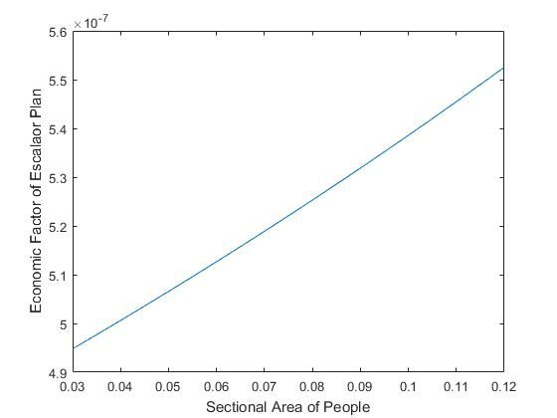

**Figure 6** Economic factor versus sectional area

We find that the larger the sectional area is, the worse the condition is. This is because larger people increase the possibility of colliding into each other. We find that the relationship between the sectional area and the economic factor is quite steady.

5.2 Sensitivity of $E_{e}$ versus the walking speed

The walking speed effects the economic factor too. The faster people walk, the less time can be wasted, and the better the economic factor is. In the figure below is the relationship between walking speeds and the economic factor of the escalator plan. It conforms to our guess.

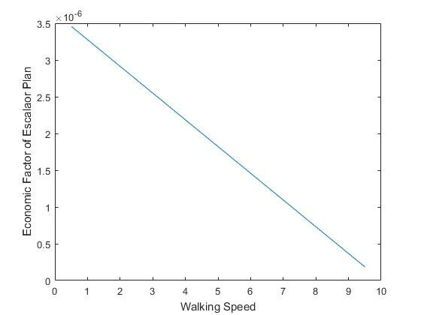

**Figure 7** Walking speed versus the economic factor

5.3 Sensitivity of $E_{e}$ versus $k$

In our model, $k$ is the vertical-horizonal distance coefficient, which means that covering one meter vertically is equal to $k$ meters horizontally. It indicates the speed of escalators, and the larger *k* is, the more time would be wasted in the transit hub. The *k* we used came from escalator parameters, and equals 6. In the figure below, we analyzed the effect of *k* on the economic factor. Its effect is stable.

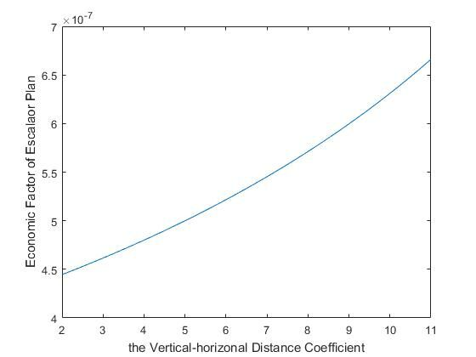

**Figure 8** The economic factor versus *k*

5.4 Sensitivity of $E_{e}$ versus the GDP

The GDP of the region decides how much money the time is worth. In our model, we used the average GDP of China to represent the GDP of H city. The sensitivity analysis in the figure below shows that the economic factor is quite sensitive to the GDP, especially when the GDP is relatively high. In real situations, the GDP of the exact region should be carefully calculated.

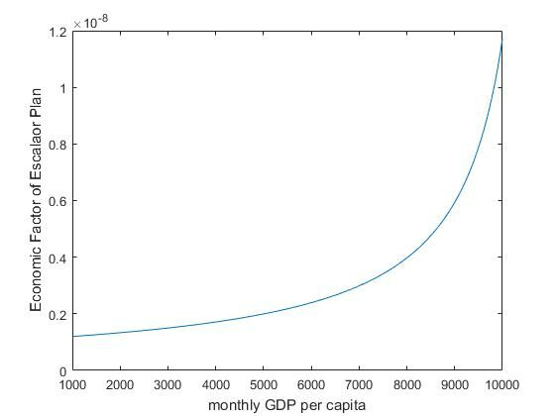

**Figure 9** The economic factor versus GDP

1. Strengths and weaknesses

6.1 Strengths

**1. Our model is quite comprehensive.**

When evaluating the plans, we considered diverse factors such as construction costs, walking distances, escalator redundancy as well as the disorder caused by passenger collision. This makes it quite comprehensive.

**2. Our model is quantitative.**

In our model, we assessed the value of time saved and escalators fully used in terms of money, which provides a quantitative overlook on our plans instead of solely qualitative comparison.

6.2 Weaknesses

**1. Our model involves a large operand**.

A As the genetic algorithm is used to optimize our plan, a large amount of calculation is required. This makes our model slow to operate and dependent on the quality of hardware.

**2. Our model used many constants.**

Our model relies on many estimated constants, such as GDP per capita which varies largely in different regions. Therefore, we must consider the choice of data with great caution.

1. References

[1] Metro designing standards, GB 50157-2013, 9.3.14, 9.7.3.

[2]Carey N. *Establishing Pedestrian Walking Speeds* [J], PSU ITE, 2005.

[3] Schmidt R., Sadre R., Pras A., *Gaussian Traffic Revisited* [D], The Netherlands, University of Twente, 2013, 1-8.

[4] World Bank, Data of China’s GDP *https://data.worldbank.org/indicator/NY.GDP.PCAP.CD?locations=CN*